Press Release 20th Aug 2013
This functioning building hosts operatic events, is home to a mix of artists and runs free monthly bike maintenance workshops – the Wheelers will be at your disposal between 1100 – 1500 on the Sat 21st Sep. It’s very much alive and kicking and busy planning ahead.
“The Town Hall deserves to be enjoyed and we’d like to open a discussion with locals and beyond about how they can see it develop”. The Limehouse Town Hall Consortium Trust
The 1000 Project also launches this same weekend, an initiative to raise £1000 to improve the building and it’s services. The first £1000 will concentrate on renovating the front entrance. to cement the idea that the Town Hall is very much operating. Donations welcome at the building or via facebook where the improvements will be charted for all to see.
But if the history of this building does interest you, you can get insight into the first 50 years of it’s life through a free audio walk available all weekend, just turn up. Creators ScreenDeep made a teaser video here to give you a feel of the space.
A physical time line will be available to add your own memories of the Town Hall or add future suggestions for its use. And of course, it wouldn’t be a Town Hall Open House with top quality homemade cake.
Limehouse Town Hall has stood proud on the Commercial Road in E14 since 1879. Famed for its political past and once serving as the National Museum of Labour History, today, it is far from a derelict building. Now it’s looking to the future and takes part in Open House; when London’s architectural gems open up to the public for free.

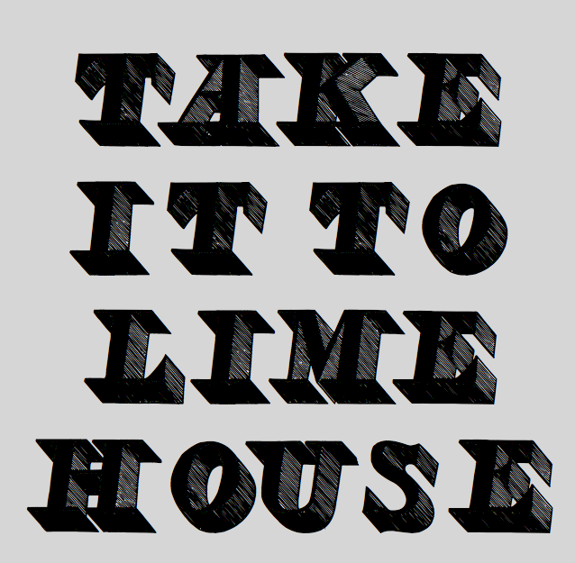

Open House Weekend runs Sat 21st & Sun 22nd Sep 2013.
Limehouse Town Hall will be open both days 1200 – 1700. Up to date info about this and
The 1000 Project on Facebook: Limehouse Town Hall
Press Enquiries: oliviabellas@gmail.com/07773 691 524

Notes to editors -
Limehouse Town Hall Consortium Trust is a registered charity with the aim of repairing and adapting the former Limehouse Town Hall to bring it back into full and sustainable community use as a means of conserving it for the future.

